TITLE: NEW PRODUCT LAUNCH – HRM-ELVP REFUGE CHAMBER RANGE

DATE: 21/02/2012
LOCATION: Perth, Western Australia
For Immediate Release.

MineARC Systems is announcing the launch of a new ultra-portable refuge chamber range designed for tight underground confines such as single entry-headings and development areas – the HRM-ELVP (Hard Rock Mine – Extra Low Voltage Portable).

Available in both 4 and 6 person configurations, the HRM-ELVP range uses a revolutionary Extra-Low-Voltage control system to power the chamber’s internal life support systems; requiring no permanent connection to mains ‘mine’ electrical power (charging required only once every 3 months).

Both the HRM4-ELVP and 6-ELVP can therefore be positioned and repositioned with ease, which is ideal for development areas where continuous drilling and blasting carries on in front of loaders, boggers and other manned units. The operational flexibility of the HRM-ELVP range, along with its small robust design, allow it to be positioned where standard refuge chambers can’t – providing personnel working in confined areas with a safe place of refuge should an emergency situation arise.

The HRM-ELVP range will supersede the popular HRM-PLP (Powerless Portable) range from MineARC Systems.

Full technical specifications are available via our website, or by contacting MineARC’s Australian Head Office on +61 (8) 9333 4966 or info@minearc.com.au

MineARC Systems

For more info on this media release please contact Ben Johnson, Marketing Manager,
on: +61 (8) 9333 4966 or ben.johnson@minearc.com.au
END//

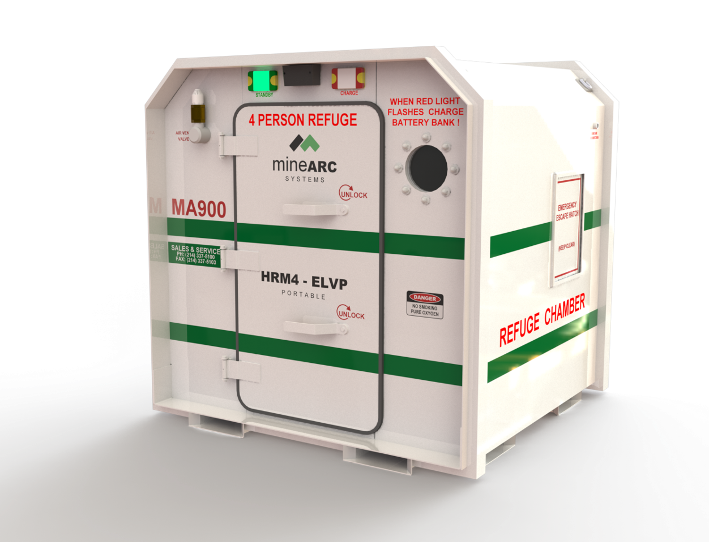
The HRM4-ELVP Refuge Chamber – front and side view

